**Homework Assignment #1**

**For this assignment you will have to submit 3 files: (1) this Word file with your answers inserted after each problem, (2) a Visio file and (3) an Access database file (as per the instructions below). Make sure you submit all 3 files together (as one submission). Do not zip the files.**

Use the database shown in the figure below to answer the following questions.

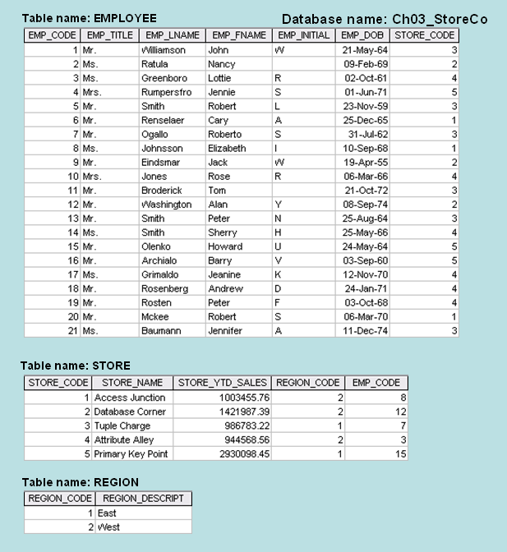

1. What is a **primary key**? Define the term **primary key**. (2pts)

Answer:

Primary key is used to ensure data in the specific column is unique.

1. What should be the **primary key** for the EMPLOYEE table? (1pt)

Answer:

Employee Code

1. What should be the **primary key** for the STORE table? (1pt)

Answer:

Store Code

1. What should be the **primary key** for the REGION table? (1pt)

Answer:

Region Code

1. What does **entity integrity** mean? Define the term **entity integrity**. (1pt)

Answer: The property of a relational table that guarantees each entity has a unique value in a primary key and that the key has no null values.

1. Does the EMPLOYEE table exhibit **entity integrity**? Answer yes/no. (1pt) Explain why or why not (2pts). Be specific and do not repeat the definition from question 5 but apply it to the EMPLOYEE table.

Answer: Yes there are no null spaces and all information is unique.

1. Does the STORE table exhibit **entity integrity**? Answer yes/no. (1pt) Explain why or why not (2pts). Be specific and do not repeat the definition from question 5 but apply it to the STORE table.

Answer: Yes there are no reoccurring keys.

1. Does the REGION table exhibit **entity integrity**? Answer yes/no. (1pt). Explain why or why not (2pts). Be specific and do not repeat the definition from question 5 but apply it to the REGION table.

Answer: Yes all information is unique.

1. What is a **foreign key**? Define the term **foreign key**. (2pts)

Answer: An attribute or attributes in one table whose values must match the primary key in another table or whose values must be null.

1. What are the **foreign keys** (if any) in the EMPLOYEE table? What table does each **foreign key** reference? (2pts)

Answer: None

1. What are the **foreign keys** (if any) in the STORE table? What table does each **foreign key** reference? (4pts)

Answer: Store_Code

1. What are the **foreign keys** (if any) in the REGION table? What table does each **foreign key** reference? (2pts)

Answer: Region_Code

1. What does **referential integrity** mean? Define the term **referential integrity**. (2pts)

Answer: A condition by which a dependent table’s foreign key must have either a null entry or a matching entry in the related table.

1. Does the EMPLOYEE table exhibit **referential integrity**? Answer yes/no. (1pt) Explain why or why not. (2pts) Be specific and do not repeat the definition from problem 13 but apply it to the EMPLOYEE table.

Answer: I believe so

1. Does the STORE table exhibit **referential integrity**? Answer yes/no. (1pt) Explain why or why not. (2pts) Be specific and do not repeat the definition from problem 13 but apply it to the STORE table.

Answer: Yes

1. Does the REGION table exhibit **referential integrity**? Answer yes/no/not applicable. (1pt) Explain your answer. (1pts) Be specific and do not repeat the definition from problem 13 but apply it to the REGION table.

Answer: Yes

1. Look at the **relationship** between the STORE and REGION tables and answer the following 2 questions regarding the **upper limit** of their participation in the relationship:
   1. Can a STORE be assigned **at most one** or **many** REGION(S)? Justify your answer. (2pts)

Answer: At most one, because a store can only be within one region.

* 1. Can a REGION have **at most one** or **many** STORE(S)? Justify your answer. (2pts)

Answer: Many Stores, because one geographical region will contain more than one store.

1. Based on your answer to the previous question, specify the **type of relationship** between STORE and REGION: **1-to-1**, **1-to-many**, or **many-to-many**. (2 pts)

Answer: 1-to-many

1. Look at the relationship between the STORE and REGION tables and answer the following 2 questions regarding the **lower limit** of their participation in the relationship:
2. Does every STORE have to be assigned **at least one** REGION? Justify your answer. (2pts)

Answer: Yes because a store lies within a region

1. Does every REGION have to have **at least one** STORE? Justify your answer. (2pts)

Answer: Yes, there are at least one store within each separate region.

1. Based on your answers to the above 4 questions (a, b, c, d), draw an **Entity Relationship Diagram** (**ERD**), using **Crow’s Foot notation**, to show the relationship between STORE and REGION. Make sure you:

* draw the attributes of each entity set (2pts)
* label the primary keys (PK) and foreign keys (FK) (3pts)
* show the upper and lower limits (that is, the **cardinalities**) of the relationship (5pts)

Insert a screenshot of your ERD here.

Look at the EMPLOYEE and STORE tables. Each store **employs** many employees, one of whom **manages** the store. So, there are two relationships between EMPLOYEE and STORE.

1. For the “employs” relationship:

* specify which foreign key (FK) captures that relationship (2 pts)

Answer: Store_Code

* formulate and answer the 4 questions regarding the upper and lower limits of the entities’ participation in that relationship (8pts) (Hint: Use as an example the questions from problems 17 and 19.)
  1. Question 1:

Answer:

* 1. Question 2:

Answer:

* 1. Question 3:

Answer:

* 1. Question 4:

Answer:

1. For the “manages” relationship:

* specify which foreign key (FK) captures that relationship (2pts)

Answer: Emp_Code

* formulate and answer the 4 questions regarding the upper and lower limits of the entities’ participation in that relationship. (8pts)

1. Question 1:

Answer:

1. Question 2:

Answer:

1. Question 3:

Answer:

1. Question 4:

Answer:

1. Based on your answers to the above questions (a, b, c, d), add to your previous **Entity Relationship Diagram** (**ERD**), the EMPLOYEE entity set and its 2 relationships with STORE. Make sure you:

* draw the attributes of each entity set. (3pts)
* label the primary keys (PK) and foreign keys (FK). (6pts)
* show the upper and lower limits (that is, the **cardinalities)** of the “employs” relationship. (5pts)
* show the upper and lower limits (that is, the **cardinalities)** of the “manages” relationship. (5pts)
* do not cross lines. (1pt)

Insert a screenshot of your ERD here. Make sure you include your Visio file in your Blackboard submission.

1. Using **Access**, create a **relational diagram** to show the relationships among EMPLOYEE, STORE, and REGION. Make sure you:
   * Create all 3 **table designs**. (3 pts)
   * Specify the **PK** for each table. (3pts)
   * **Populate** all 3 tables with the data shown in the above figure. (Note: For the EMPLOYEE table you can add only the rows referenced by the STORE table.) (3 pts)
   * Create the **3 relationships** that exist between these tables (3pts) (Note: In Access, when you add a second relationship between 2 tables, a new alias table is automatically added to the relational diagram. The only purpose of this table is to store the relationship.)
   * **Enforce referential integrity** on all 3 relationships, so that the relationships show multiplicities (1-to-1 or 1-to-∞) (3pts)
   * **EXTRA CREDIT** (5 pts): Specify what constraint needs to be added to the database so that the “manages” relationship becomes 1-to-1 (instead of 1-to-∞). Add this constraint to your Access database.

Insert a screenshot of your relational diagram here. Make sure you include your Access file in your Blackboard submission.